IC DATA SHEET :-

1. IC 7400

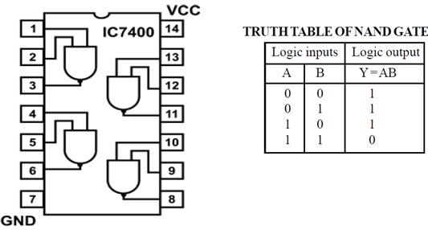

1. IC 7402

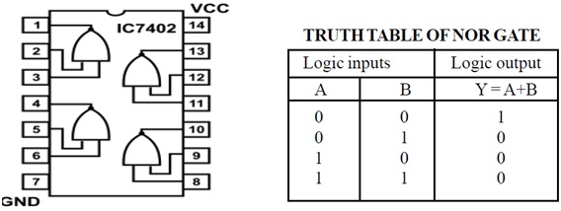

1. IC 7404

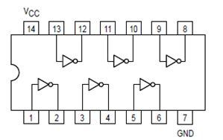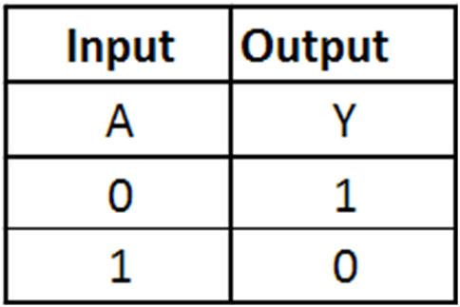

1. IC 7408

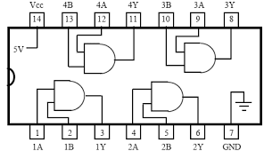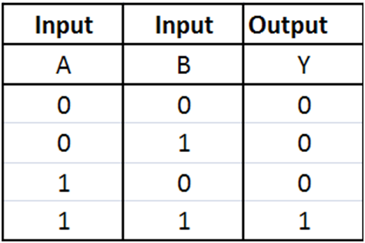

1. IC 7410

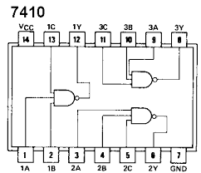

1. IC 7420

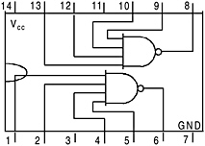

1. IC 7430

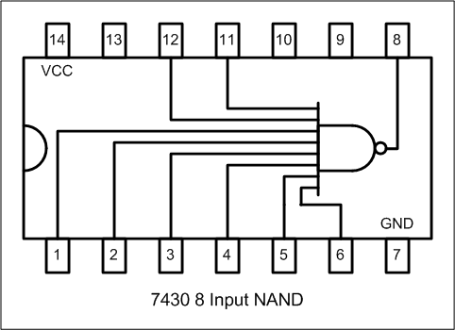

1. IC 7432

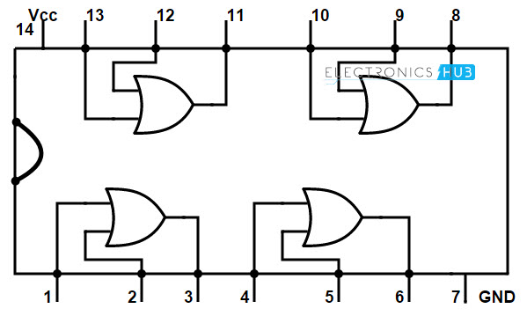 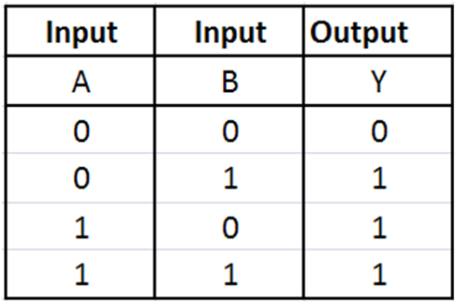

1. IC 7486

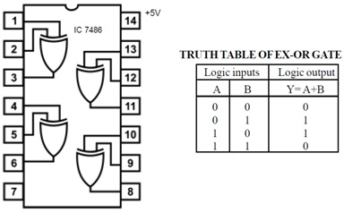

1. IC 7483 (parallel adder and subtractor )

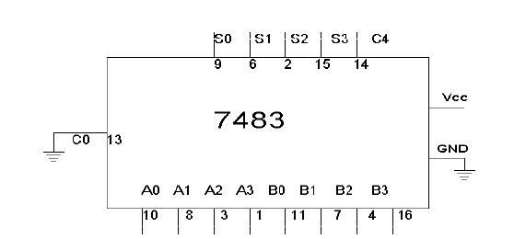

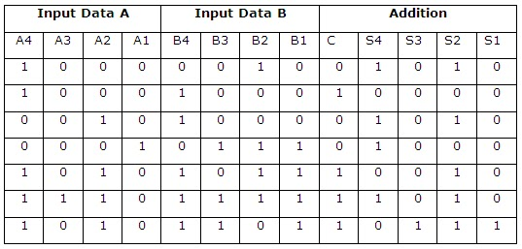

1. IC 7485 (compartor )

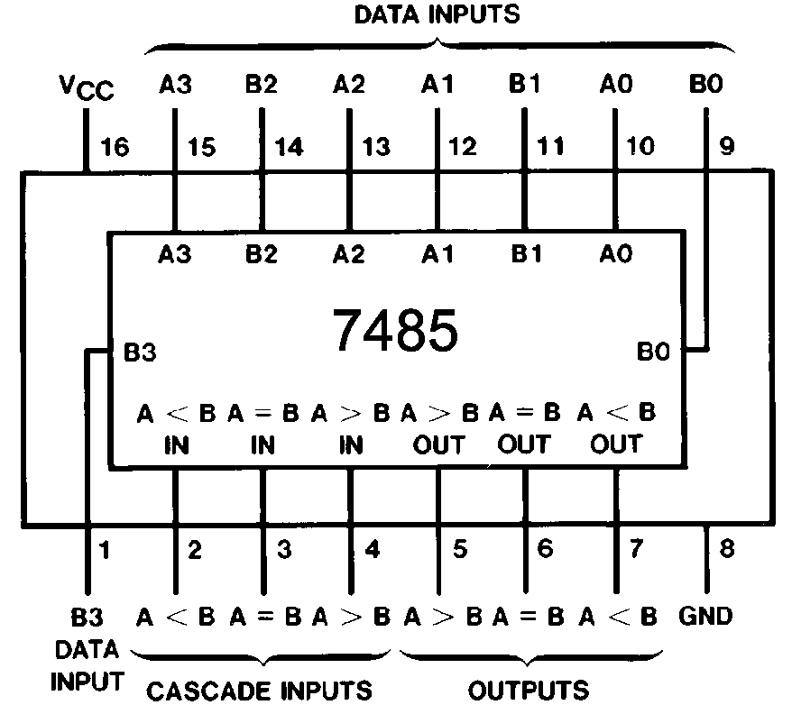

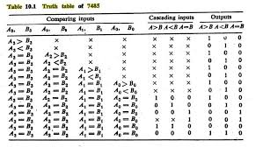

12. IC 74153 ( MUX)



**TRUTH TABLE**

**S1 S0 E I0 I1 I2 I3 Y**

X X 1 X X X X 0

0 0 0 0 X X X 0

0 0 0 1 X X X 1

0 1 0 X 0 X X 0

0 1 0 X 1 X X 1

1 0 0 X X 0 X 0

1 0 0 X X 1 X 1

1 1 0 X X X 0 0

1 1 0 X X X 1 1

13. IC 74139 (dual 2: 4 Demux)

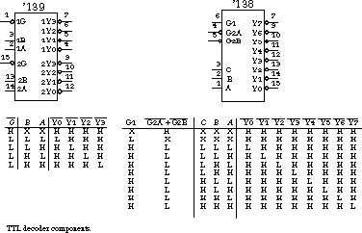

14. IC 74147 ( decimal to BCD )



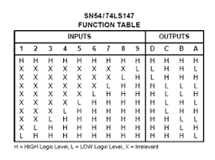

15. IC 74148



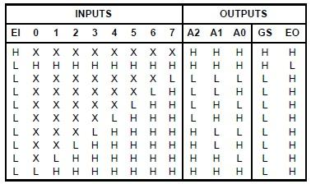

16. IC 7447 (LED)



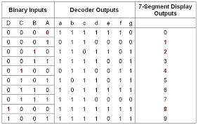

17. IC 7448 (LED)

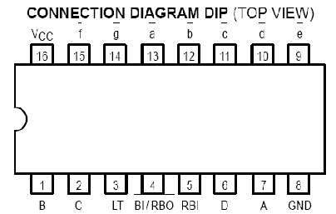 truth table is same as above

18. IC 7476 (JK Flip flop)

